Artnet News

February 21, 2022
In Pictures: See How a New Cohort of Contemporary Textile Artists Are Taking Quilting in Challenging New Directions

https://news.artnet.com/art-world/the-new-bend-2072590
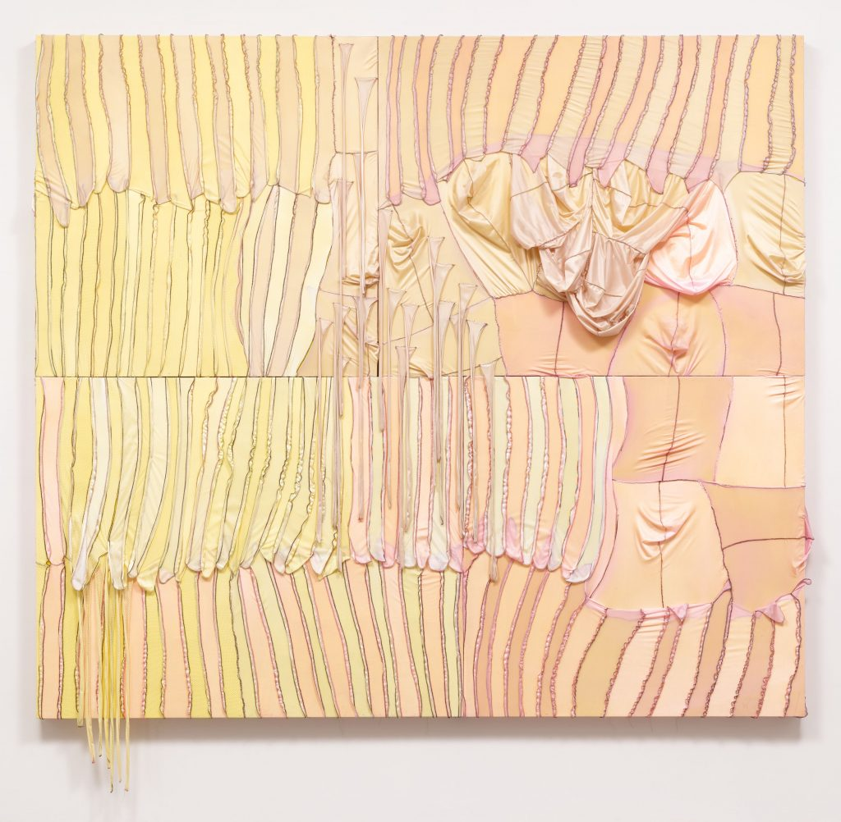
In a new show at Hauser & Wirth curated by Legacy Russell, artists embrace the history of quilting and apply contemporary considerations of gender, class, and technology. Twelve individuals—Anthony Akinbola, Eddie R. Aparicio, Dawn Williams Boyd, Diedrick Brackens, Tuesday Smillie, Tomashi Jackson, Genesis Jerez, Basil Kincaid, Eric N. Mack, Sojourner Truth Parsons, Qualeasha Wood, and Zadie Xa—comprising Russell’s presentation of “The New Bend” use textiles to continue the tradition of storytelling in art history.

